PART 2 (70 marks = 35% of paper)

Answer ALL questions in Part 2 in the spaces provided below. ________________________________________________________________________

- Write equations for any reactions that occur in the following procedures. If no reaction occurs write 'no reaction'.

In each case describe in full what you would observe, including any
• colours
• odours
• precipitates (give the colour)
• gases evolved (give the colour or describe as colourless).
If no change is observed, you should state this.

(a) Chromium metal is added to dilute sulfuric acid.

Equation ________________________________________________________________

Observation ________________________________________________________________________

________________________________________________________________________
[3 marks]

(b) Aluminium metal is added to a solution of sodium hydroxide.

Equation _______________________________________________________________________

Observation ________________________________________________________________________

________________________________________________________________________
[3 marks]

(c) Solid sodium sulfite is added to warm hydrochloric acid.

Equation ________________________________________________________________________

Observation ________________________________________________________________________

________________________________________________________________________
[3 marks]

2. For each species listed in the table below draw the structural formula, representing
All valence shell electron pairs as : and indicate the shape of the species by either a sketch or a name.

Species | Structural formula  (showing all valance electrons) | Shape  (sketch or name)
Oxygen difluoride,
OF₂

Carbon disulfide
CS₂
Azide ion,
N₃⁻

[6 marks]

3. The electron configuration of a lithium atom is 1s² 2s¹. Using the same notation, give the electron configuration of

a) a fluorine atom F ____________________________________

b) a calcium ion Ca²⁺ ___________________________________
[2 marks]

4. On the Axes below sketch a graph to show the following

a) How the melting points of the elements of the third period vary from left to right.

Melting point

Na Mg Al Si P S Cl Ar [3 marks]

b) The first six successive ionisation energies of Germanium. (3 marks)

Ionisation energy

1st 2nd 3rd 4th 5th 6th [2 marks]

5. In the presence of nitric acid, sulfur is oxidised to sulfur dioxide and nitric acid is reduced to nitrous oxide (NO). Write two half equations and a full balanced equation for this reaction.

Reduction half-equation

Oxidation half-equation

Full equation

[6 marks]

6. A student performed a neutralisation reaction outlined as followed: She took care to ensure complete neutralisation had occurred, with neither acid nor base in excess. She then used an indicator to measure the pH of the final reaction mixture. When she did this procedure with hydrochloric acid that was neutralised with sodium carbonate solution the final pH was approximately 10. She thought the pH would have been 7. Account for the observed pH value she found and suggest a possible acid/base combination which would lead to these observations.
[4 marks]

7. Briefly explain each of the following. Where appropriate, use examples to illustrate
your answer.

a) Metals are excellent conductors of electricity but ionic solids are non-conductors.

[4 marks]
b) Iodine is a solid at room temperature while chlorine is a gas.

[4 marks]
c) The ionisation energies of alkali metals decrease with increasing atomic number.

[4 marks]

8. In 1937, while carrying out research on organo-phosphorus insecticides, a scientist in Germany discovered the nerve gases. The first of these gases was called Tabun. A splash of 0.0002g of Tabun on the skin of a person is fatal in a few minutes through paralysis and respiratory failure.

Tabun has the structural formula:

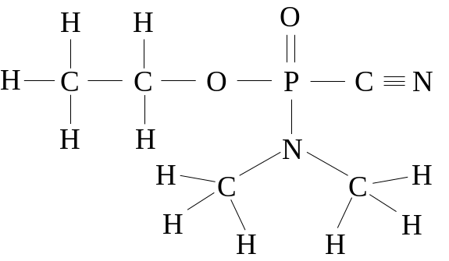

(a) Write down the empirical formula of Tabun.

_____________________________ [1 mark]

(b) Calculate the percentage of phosphorus in Tabun:

(i) by mass.

[3 marks]

(ii) by number of atoms per molecule.

[2 marks]

9. What are the characteristics of a primary standard, and explain why sodium carbonate is a good primary standard whilst sodium hydroxide is not. [4 marks]

10. During a titration, you should rinse the burette, pipette, and conical flask with certain solutions. If you are doing a standard acid base titration, how would you rinse each instrument and why?

a) Burette

[3 marks]
b) Pipette

[3 marks]

c) Conical flask

[3 marks]

11. The first eight ionisation energies (in eV) for a certain element are:

10.49 19.72 30.18 51.37 65.02 220.43 263.21 309.41

a) Account for:

(i) the general increase in these values. [2 marks]

(ii) any discontinuities in the general trend. [2 marks]

(b) Identify the group to which this element most probably belongs. [1 mark]

__________________
12. Given the following equation

NH₃ + H₂O → NH₄⁺ + OH⁻

Which is the

Acid ________ Base __________

Conjugate acid _________ Conjugate base __________
[2 marks]

